Multiple choice section

|  |  |  |  |  |  |  |  |  |
| --- | --- | --- | --- | --- | --- | --- | --- | --- |
| Question | 1 | 2 | 3 | 4 | 5 | 6 | 7 | 8 |
| Answer | D | A | D | B | C | B | A | D |

Question 1 [3.1]

D



Question 2 [3.1]

A



Question 3 [3.2]

D



Question 4 [3.4]

B



Dilation factor = 2, the coefficient of *x*2

Question 5 [3.4]

**D**



Question 6 [3.5]

B

Using cross method  
 8 = -2 × -4, -6 = -2 + -4



Question 7 [3.6]

C

Using the difference of two squares



Question 8 [3.7]

A



Multiple-choice total marks: 8

Short answer section

Question 9 2 marks [3.2, 3.5]

(a) *Factorising* involves taking out the highest common factor of terms.

(b) Expressions containing variables in fraction form are *algebraic fractions*.

Question 10 2 marks [3.6]

A difference of two squares is an expression of the form , which can be factorised as . For example, 

Question 11 2 marks [3.1]



Question 12 4 marks [3.1]

(a)



(b)



Question 13 2 marks [3.1]



Question 14 3 marks [3.2]

**(a)** Each term contains 2*d*, so the HCF is 2*d*.

**(b)** 

Question 15 4 marks [3.2]

**(a)** Area = length2  
= (2*x*)2  
= 4*x*2

**(b)** Area = π*r*2  
*r* = 2*x* ÷ 2 = *x*  
Area = π × *x*2  
= π*x*2

**(c)** Shaded area = area of square – area of circle  
= 4*x*2 – π*x*2

**(d)** 4*x*2 – π*x*2 = (4 – π)*x*2

Question 16 3 marks [3.4]

 from 

 to  Dilation factor of 4.

Graph becomes ‘thinner’ by a factor of 4.

 to 

Horizontal translation of 2 units to the right.

 to .

Vertical translation of 5 units.

Question 17 3 marks [3.4]

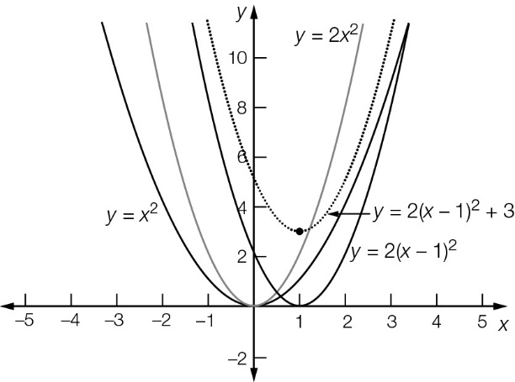

Question 18 3 marks [3.6]

6*a*2*b*2 – 24*w*2

= 6(*a*2*b*2 − 4*w*2)

= 6((*ab*)2 − (2*w*)2 )

= 6(*ab* − 2*w*)(*ab* + 2*w*)

Question 19 3 marks [3.7]



Question 20 3 marks [3.7]



Short answer total marks: 34

Extended answer section

Question 21 5 marks [3.1]

|  |  |  |
| --- | --- | --- |
| **(a)** | **(b)** | **(c)** |

Question 22 5 marks [3.5, 3.6]

**(a)** 

**(b)** 

**(c)**



Question 23 6 marks [3.5]

**(a)** At   m

**(b)** 



(c) The ball will hit the ground where h = 0. This is when t = 12.  
The value t = -2 is not possible because time must be positive.

Question 24 5 marks [3.1, 3.2]

|  |  |  |
| --- | --- | --- |
| (a) | (b) First rectangle area: a(a – x) Second rectangle area: bx Total area:  a(a – x) + bx = a2 – ax + bx | (c) Area of large rectangle: a2  Area of C: x(a – b)  Area of carpet: a2 – x(a – b) = a2 – ax + bx |

Extended answer total marks: 21

TOTAL test marks: 63